03/03/06

Dr. Gerhing’s third lecture on Mass Spectrometry (MS) went into detail about how to decipher multiple charges on a spectrum and the applications of MS.

In most MS we look at proteins or peptides where peptides are ionized by the loss of a proton. In general, you could calculate the mass of the peptide by multiplying the mass to charge ratio (m/z) by the charge z, which would yield m. However, as we will see, it is not this simplistic.

The computer calculates the mass of each peak by determining what the least common multiple is of the m/z values. To illustrate this concept, consider the numbers 3, 4 and 5. The lowest number that they are all a multiple of is 60. At an m/z ratio of 3, the charge would be 20 because 60/3 = 20. Similarly, the charge at an m/z of 4 and 5 would be 15 and 12 respectively. However, this doesn’t take into account the difference in mass due to additional proton charges. We use a formula to determine the mass of successive peaks.

Generally in a spectrum, peaks come in positions of (m +z)/z.

For two adjacent peaks P₁ and P₂, the formula to calculate the mass (which will be the least common multiple of the peak numbers) for a protein is:
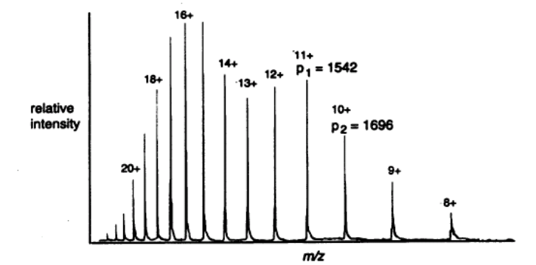
1 = 1 - 1
M (P₂ – 1.008) (P₁-1.008)

Where P_{i} is the peak value of m/z at a specific peak on the spectrum, as shown in the figure to the right, and M is the ‘base mass’ of the protein i.e. the mass with no excess bound protons and the net charge is zero. The value 1.008 is subtracted from the peak value m/z, as this is the mass of each additional positive charge due to protonation from the ‘base mass’ (and obviously, from one protonated state to the next, there will be a difference of one proton).

Likewise, for a nucleic acid that is negatively charged, the proton mass is added to the peak value m/z, as each successive peak is losing mass.

1 = 1 - 1
M (P₂ + 1.008) (P₁+1.008)

So with an MS, you have to tell it whether you’re losing or gaining a charge and the mass associated with that charge.

Aside: Gehring used P in class to represent the value of m/z, but the handout uses m/z. I will use m/z from here on in.

So Gehring will give us a set of peak numbers and ask us to calculate what the mass of the peptide is. So we use the above formula to calculate what m is for the peaks

The above equations give a good estimate for M, which then allows us to estimate the number of excess protons (n) bound as positive charge to give a peak i using the equation:

(m/z)_{peak i} = (M/n_{peaki}) + 1.008 We have our estimate of M, so we can calculate n_{peaki} (but note that the value will have to be rounded to the nearest integer since it is the number of protons)
After we have determined the charge associated with each peak, we can determine the charge on the adjacent peaks, knowing that lower m/z ratios have a higher charge and higher m/z ratios have a lower charge (the figure above illustrates this).

Finally, knowing the charge on each peak, the mass M can be calculated for each individual peak using the equation:

M = n_{peaki} ([m/z]_{peaki} - 1.008)

By using several independent estimates of the molecular weight, the expected error is smaller than if we were to use one estimate alone, based on statistical principles.
The spectrum below will be used to illustrate the averaging of molecular weights.

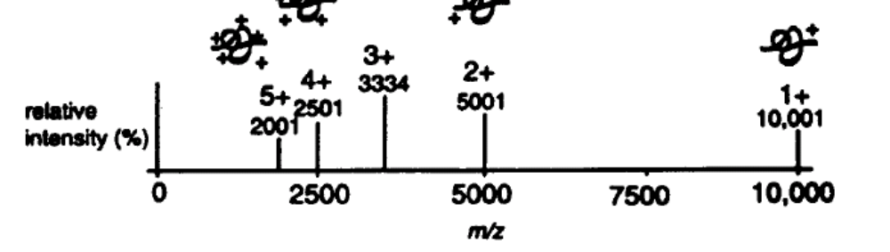
So M= 1/5[1(10 001-1.008) + 2(5001-1.008) + 3(3334-1.008) + 4(2501 – 1.008) + 5(2001-1.008)] = 9999.776 Da

This is the way the computer calculates the mass of the spectra.

Sodium as an ionizing agent:

When preparing samples for MS it is important to desalt the sample, otherwise Na+ ions can complex with your protein instead of a proton. If this were to happen, you would have a spectrum with peaks shifted by 23, the mass of sodium. The formula to calculate the mass in this case would be:
M= 1/([m/z]_{peak2} - 23) - 1/([m/z]_{peak1} - 23)

How do you get multiple charges on the protein? To a good approximation, it is the number of Lys or Arg available on the peptide. You can use MS to determine if your peptide is folded or unfolded.

In an unfolded protein more Lys and Arg residues are available to be ionized, so if you run a protein sample under native and denatured conditions, you’ll get a shift in the distribution of charges, as seen below.
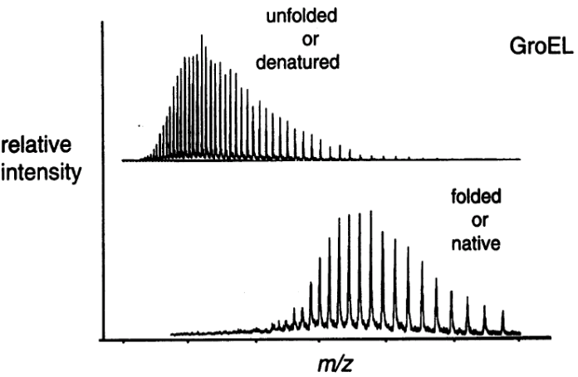

In the native state, the number of average charges is lower than in the unfolded state because there are fewer Lys and Arg at the surface. To increase the number of charges, look at peptides at low pH, and then you can work at higher molecular weights.

Generally, to increase the number of charges, look at peptides at low pH, and then you can work at higher molecular weights. This is because the “z” values will increase, and allow for higher “m” values, while maintaining a similar “m/z” value.

Applications of MS:
- Measure the Folding Rates of Proteins: Deuteration
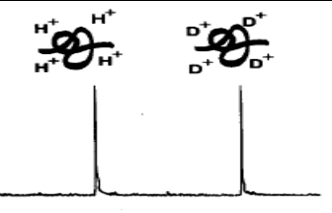
A protein folded in normal water will have protons on it. If you mix it with a protein folded in heavy water, deuterium, the protons on the hydroxyl groups, backbone amides and Lys residues will exchange with the solvent. This exchange will yield a difference in mass between the two peaks and you can measure how many exchanges took place. You can also do kinetic experiments where the protein starts off as deuterated and ends up as protonated by allowing it to exchange deuterium for hydrogen in light water to measure the rate of hydrogen ion exchange. Less tightly bound deuterium will exchange more quickly, and tightly bound deuterium will exchange more slowly. The rate of exchange can be measured simply by measuring the mass of the peak of the protein.

- Sequencing Peptides and Identifying Proteins:
  - Carboxy Peptidase: systematically removes residues so you can get a series of peaks, which all differ by the mass of one residue. By measuring the mass differences between peaks, you can determine the mass of the residue that has been cleaved. One problem with this method is that you can’t determine the difference between Leu or Ile because they have identical masses or Lys and Gln because the masses are too similar to distinguish by MS. Furthermore, the method is not synchronous, so you can get different lengths of peptide. This can be avoided if you degrade the peptide slightly and run a MS and measure all the masses together and this way you can read off the sequence where the intact peptide will have the highest mass.

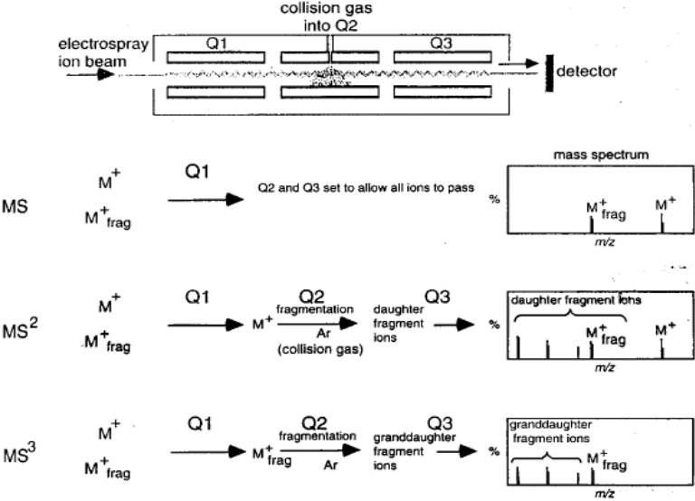
  - Edman Degradation: In earlier years, the degradation needed to be done before the MS was taken, but now it can be done in the MS by doing fragmentation. An Electronspray Quadrapole Filter MS is used where you can select the masses of the ions that go through and detect them at the end in the detector. The spectrum is acquired by either sweeping the filter on Q1, Q2 or Q3, which in each case will give you the spectrum of your ions (called straight MS). If you introduce a neutral gas like Argon at the Q2 filter, some of the ions will collide with Argon and fragment. The path of fragmentation is called CID, Collision Induced Dissociation. If you only sweep Q1, you will get two peaks, because you have two peptides (shown in the spectrum above). You can then select one of the peaks and fragment it to get smaller ones. Alternatively, you could take a mixture of peptides and in the first filter select one ion that then goes intoQ2, gets fragmented, and then you take the spectrum of the all the fragments. The spectrum of the fragments (also known as daughter fragments) will allow you to sequence the peptide.

But with fragmentation, the backbone can break at either the C-C bond, the N-Cα bond or at the peptide bond (where the majority of breakage occurs). Depending on where fragmentation takes place, you can get a variety of different ions. There is a specific nomenclature associated with where the break occurs. If the daughter fragment contains the N-terminus it is known as b1, and the daughter fragments with the C-terminus are known as y3.

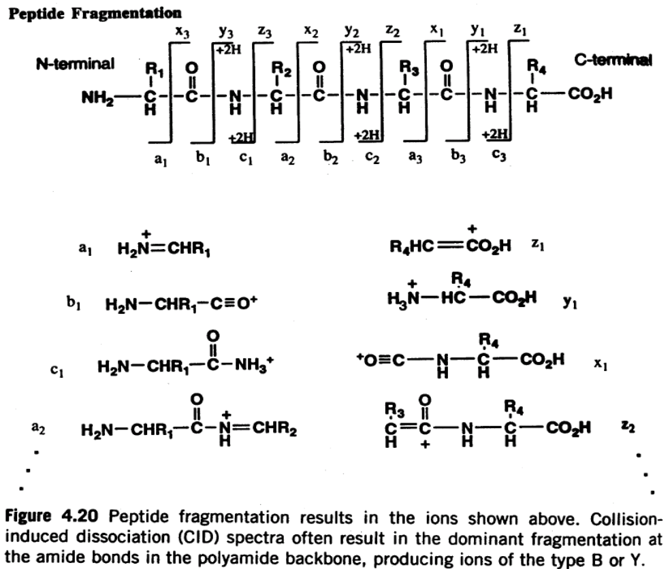

In the figure above, if the fragmentation occurs at a₁, the corresponding ion will be z₁ and for b₁ it will be y₁ and so forth. In a spectrum, major peaks will be seen as b and y fragments, as these correspond to the peptide bond, and minor peaks will be seen as a and z and c and x fragments.

For every peak, there are two possibilities; it either contains the N-terminus or C-terminus. By looking at the steps in here, the computer is able to predict what the original sequence of the peptide was.

How Proteomics Developed with MS

The Handout entitled “Mass spectrometry-based proteomics” details the use of MS with proteomics. Generally, the protein of interest is digested with trypsin and an MS-MS (magnetic sector MS) is performed (aka Tandem MS). The trypsin digestion is passed through the FAB-MS with little or no fragmentation and then the product ions of different m/z ratios are separated by mass in Magnetic sector 1 with a resolution up to 1 Da. After the separation, the ions of a specific m/z ratio are accelerated to a high velocity and passed into a chamber containing He, Xe or Ar in CID. The charged fragments are then separated by mass for a second time through Magnetic Sector 2 and detected. In the figure below, each ion corresponds to a different peptide, therefore you can get a list of peptide sequences used to predict the protein, but you need a few peptides well sequenced to identify your protein with high certainty, where the more peptides you can sequence, the more sure you are about what the protein is. This is done on an automated, large scale.

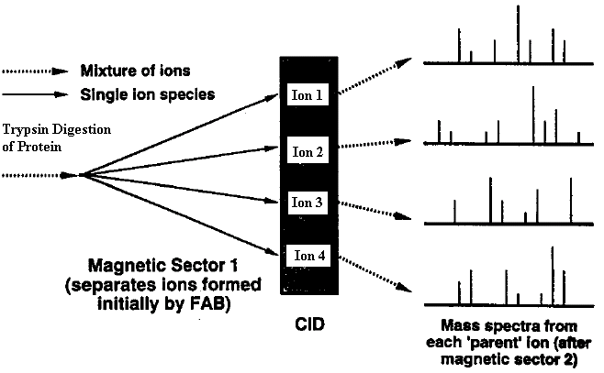

An Application

Dr. Gehring went through an example from a protein in his lab to illustrate the deductive process involved in MS.

- In the spectrum below the peak at 1579.7 was blown up to examine the smaller peaks within. At first glance, it would appear that the additional peaks are due to the presence of Carbon 13, however upon closer analysis, it can be seen that the peaks are in fact separated by an average of 4.4 m/z units, which corresponds to a mass of 22 Da (4.4 m/z x 5z = 22). The reason for this discrepancy was due to the presence of sodium ions in the sample, because the sample was not carefully desalted. The molecular weight of sodium is 23, but since the molecular weight was 22, it was concluded that protonation was also occurring, thus the difference in molecular weight would be 23-1=22. Therefore, proper sample preparation is very important in MS.

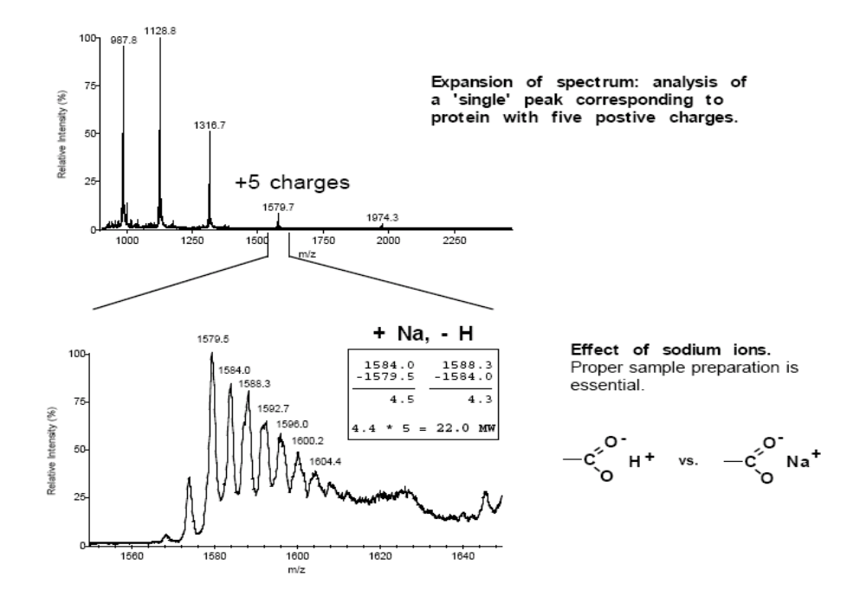

- The sample was sufficiently desalted and a second MS was performed and the following spectra resulted:

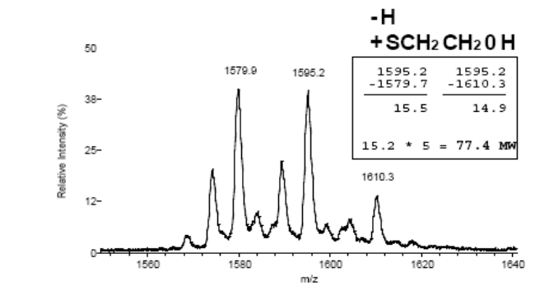
Now the molecular weight difference was 77.4 Da. It was discovered that β-mercaptoethanol was adducting the protein through the formation of disulfide bonds. The molecular weight of β-mercaptoethanol is about 79, but two protons are lost when you make the disulfide bond. So there

was incomplete sulfide bond reduction of the sample.

- The sample was reduced more efficiently, but there were still two peaks in the MS, so it was hypothesized that the mass discrepancy was due to a formyl group on methionine. Proteins in bacteria are made with a formyl-methionine, but usually the formyl group is removed, but perhaps it was present at the N-terminus to change the mass by about 28.
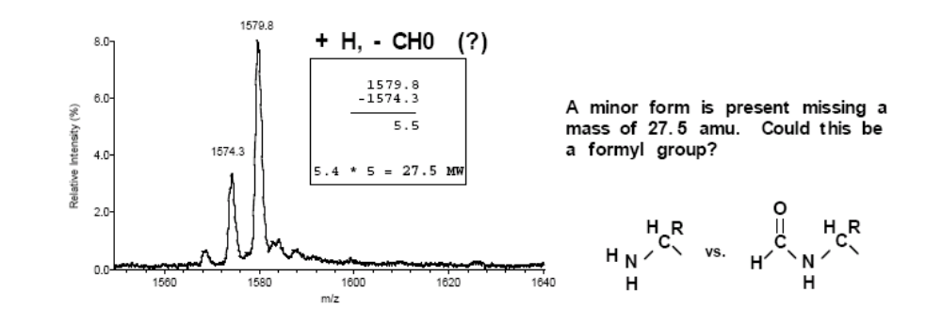
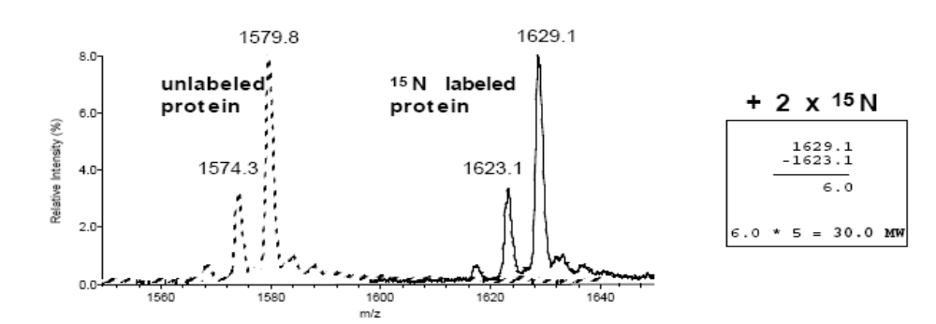
So to confirm this, a protein sample labeled with ¹⁵N was used to perform MS. This new spectrum showed a peak with a mass difference of 30 compared to 28 for the ¹⁴N. So in fact, the formyl group hypothesis was incorrect. (If a formyl group was present you would expect to see a peak shift of 29)

- They then used a table of amino acid residue masses to look for differences between amino acids that correspond to a difference of 28. There are two substitutions that could produce this discrepancy: an Arg residue to a Lys or an Arg to a Gln. They were able to figure out that half the plasmids were mutated where an Arg was replaced with a Lys or Gln. And needless to say, the project was dropped.

